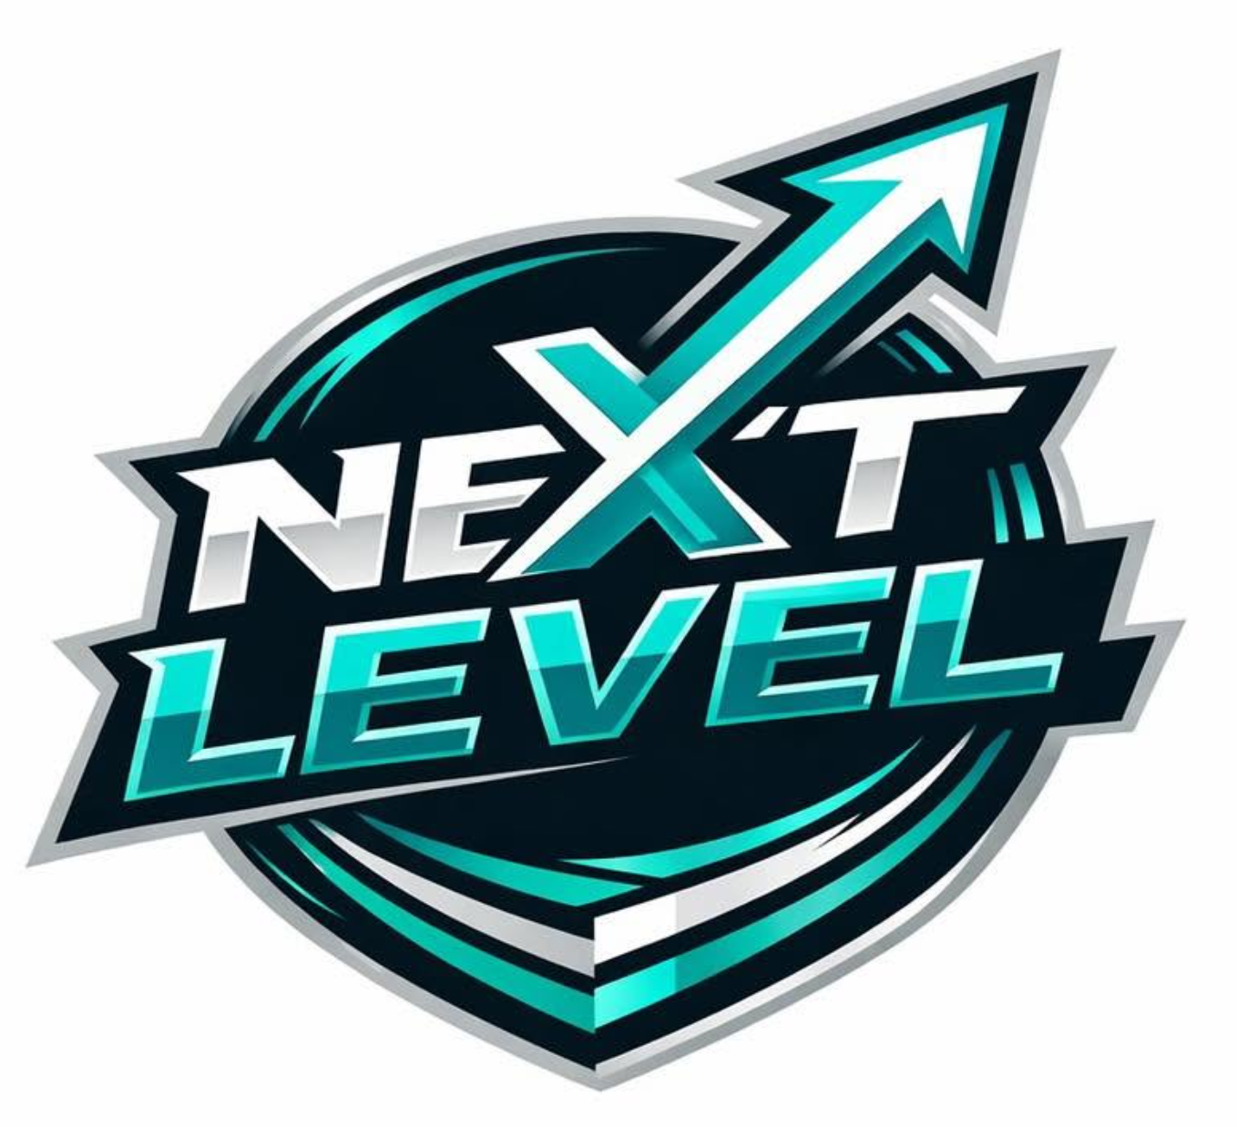
NEXT LEVEL
Netball Player code of conduct

POLICY STATEMENT
Thank you for being part of Next Level Club. We want every player to enjoy netball, improve their skills, and be part of a positive, supportive team.
As a competitive club, we encourage all players to work hard, show respect, and always give their best. Team selections are made by our coaching team based on effort, attitude, development, and what is best for the team. We ask all players to trust and respect these decisions.
As a player at Next Level Netball, you are an ambassador for our club. Whether you are at training, matches, tournaments, or using social media, your behaviour reflects our values. We expect every player to help create a positive, welcoming, and supportive environment where everyone feels respected, encouraged, and proud to be part of the club.
Netball will bring both successes and challenges. By staying positive, working hard, and showing resilience, you will continue to improve both on and off the court.

PLAYERS SHOULD
- Always try their best at training and matches.
- Show respect to coaches, teammates, opponents, umpires, and spectators.
- Play fairly and follow the rules of the game.
- Arrive ready to play with the correct kit, suitable trainers, hair tied back, no jewellery, and short fingernails.
- Warm up properly before training and matches.
- Support teammates and encourage others to create a positive environment for everyone to learn and grow their skills.
- Be open to making new friendships that create dedicated team bonds.
- Wear the correct club kit for matches.
- Represent Next Level Club in a positive way both on and off the court, including on social media.

PLAYERS SHOULD NOT
- Argue with or show disrespect towards umpires, coaches, officials, teammates, opponents, or spectators.
- Use rude, offensive, bullying, intimidating, or discriminatory language or behaviour.
- Disrupt training sessions, matches, or team meetings by refusing to listen or follow instructions.
- Display a negative attitude, poor sportsmanship, or behaviour that affects the enjoyment of others.
- Exclude teammates or deliberately make others feel unwelcome.
- Criticise, blame, or argue with teammates during training or matches.
- Use mobile phones during training or games unless given permission by a coach.
- Damage club, venue, or other people’s equipment or property.
- Post or share inappropriate, offensive, or negative comments, images, or videos on social media that could upset others or bring Next Level Club into disrepute.
- Use inappropriate language or behaviour that does not reflect the values of Next Level Club.
.

WHEN CODE OF CONDUCT IS BROKEN
If a player does not follow this Code of Conduct; the club may take one or more of the following actions:
- A verbal reminder or warning.
- Time out from part or all a training session or match.
- Parents or guardians will be informed where appropriate.
- A meeting with the coaching team or club committee.
- Temporary suspension from club activities.

DECLARATION
All situations will be dealt with fairly, and players will always have the opportunity to explain their actions.
If you see or hear behaviour that goes against this Code of Conduct, whether it involves another player, a parent, a coach, or anyone connected with Next Level Netball, you should tell a trusted member of the club as soon as possible. Speaking up helps us keep our club safe, respectful, and welcoming for everyone. All concerns will be taken seriously and dealt with fairly and appropriately.

By being a member of Next Level club, you agree to follow this Code of Conduct and help create a positive, respectful, and enjoyable environment for everyone.

