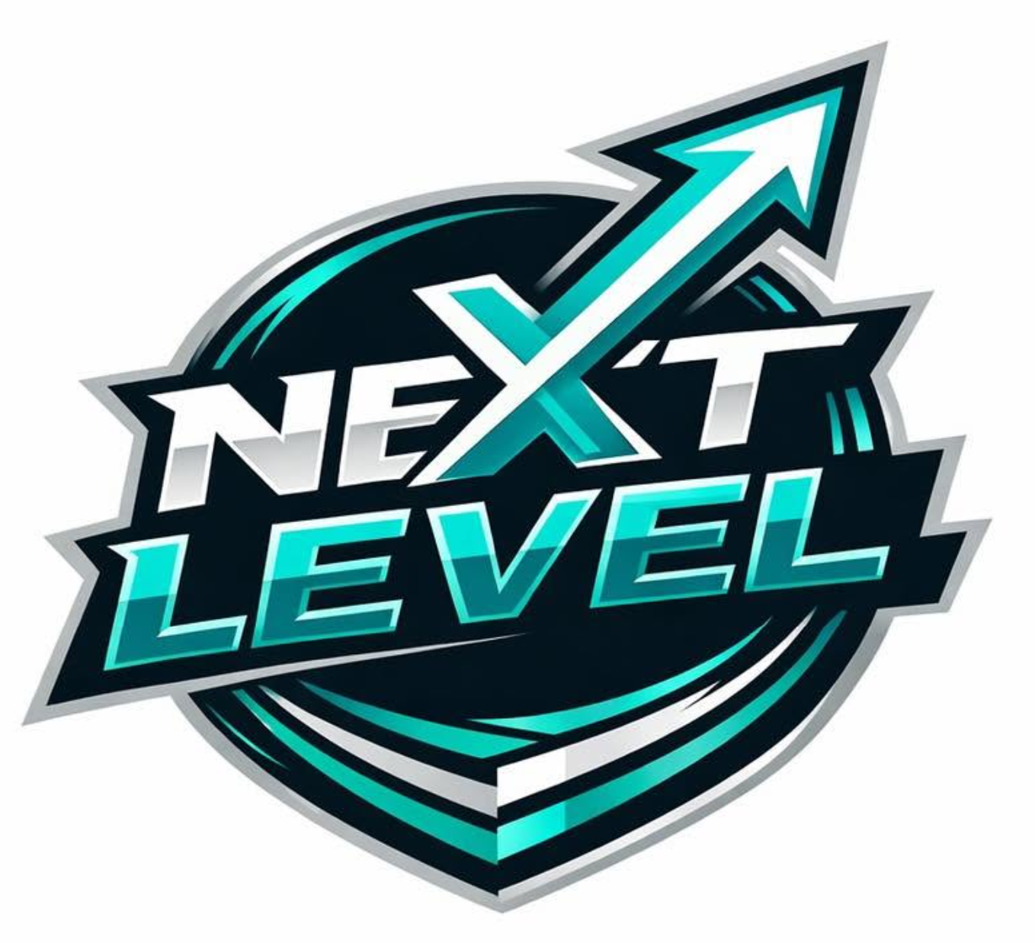
NEXT LEVEL
SOCIAL MEDIA POLICY

1. POLICY STATEMENT
At Next Level Club, we believe social media is a fantastic way to connect with our members, celebrate achievements, share club news, and promote the sport. We encourage all players, coaches, volunteers, officials, parents, and supporters to use social media positively to help build an inclusive and supportive club community.
We ask everyone associated with the club to use social media responsibly and respectfully. Posts, comments, messages, and shared content should reflect our club values and never be used to bully, harass, intimidate, discriminate against, or abuse others. Members should also avoid sharing misleading information or content that could damage the reputation of individuals, the club, or the wider community.
This guidance is designed to help everyone understand how to use social media safely and appropriately while representing Next level Club. By following these expectations, we can create a positive online environment that reflects the welcoming, respectful, and inclusive culture of our club.
Together, we can use social media to celebrate our successes, support one another, and encourage more people to enjoy sport.
The purpose of this policy is to:

- Ensure the safety and wellbeing of everyone when using the internet, social media, or mobile devices.
- Provide Staff, Volunteers, Members, and connected participants with the overarching principles that guide our approach to online safety.
- Ensure that, as an organisation, we operate in line with our values and comply with legal requirements regarding the use of online devices.

2. SCOPE AND DEFINITIONS
Child or Young Person means anyone under the age of 18, as defined by England Netball and in law.
Safeguarding means protecting children from abuse and maltreatment, preventing harm to their health or development, ensuring they grow up with safe and effective care, and taking action to enable all young people to have the best outcomes.
Wellbeing means a person’s state of mental and physical health and resilience. Many safeguarding concerns relate to general wellbeing rather than abuse; these are still taken seriously.
Club Safeguarding Officer (CSO) is the person with lead responsibility within the club for ensuring safe recruitment, appropriate DBS checks, safeguarding awareness and acting on concerns in accordance with England Netball policies.
Responsible Adult means the adult assigned to any match or event where a player under 18 is present who is not the on-court coach, and who takes responsibility for the welfare of the young player(s) at that event.
Position of Trust means someone who holds a position of power or influence over those under 18. Coaches, volunteers and club officials occupy a position of trust in relation to young players.
Social media - is the collective of online communications and media channels dedicated to community-based input, interaction, content-sharing and collaboration via a range of technologies such as desktop, laptop, tablets, smartphones, gaming consoles and platforms, and other internet enable devices. Websites and applications dedicated to forums, micro blogging, social networking, social bookmarking, social curation, and wikis are among the diﬀerent types of social media and examples of Social Media platforms include, but are not limited to, Facebook, YouTube, X, Google+, WhatsApp, Instagram, TikTok, Snapchat,
Pinterest, LinkedIn, and Reddit.

3. GUIDANCE FOR QUAILITY USAGE
Next Level Club encourages members to use social media responsibly and to maintain separate personal and club-related accounts where possible. This helps distinguish personal views from club communications and protects both individual privacy and the Club's reputation.
Members should be aware that information shared online may be publicly accessible and remain available indefinitely. Before posting, individuals should consider whether their content is appropriate, respectful, and consistent with the values of the Club. Members are expected to protect their personal information, use appropriate privacy settings, and exercise caution when interacting online. The Club has a zero-tolerance approach to cyberbullying, harassment, discrimination, grooming, exploitation, or any other behaviour that may place individuals at risk.
Any concerns regarding inappropriate online conduct or safeguarding should be reported promptly to the Club Committee or Club Welfare Officer in accordance with the Club's safeguarding procedures.

Social Media Communication
Next Level Club is committed to ensuring that all online communication is safe, appropriate, and consistent with the Club's safeguarding responsibilities.
Club-related communication should take place through official Club social media accounts or approved communication platforms. Where possible, these accounts should be managed by more than one authorised administrator to ensure transparency and continuity.
Adults in positions of trust, including coaches, volunteers, committee members, and officials, must not use personal social media accounts to communicate privately with members under the age of 18. Friend or follow requests between adults in positions of trust and junior members should not be accepted. Any necessary communication with junior members should take place through approved Club channels and, where appropriate, include parents or carers.
Members are expected to:
- Protect their personal information by using appropriate privacy settings.
- Consider carefully the content they publish and ensure it reflects the Club's values.
- Use official Club accounts for Club-related communications where authorised.
Members must not:
- Engage in private online communication with junior members through personal accounts.
- Post content that is offensive, discriminatory, abusive, or likely to bring the Club or the sport into disrepute.
- Represent personal opinions as official Club statements without authorisation.
The Club recognises that parents and carers may monitor their own child's social media activity. However, this policy applies to relationships established through the Club and is intended to promote safe, respectful, and appropriate online interactions for all members.
EXPRESSING AN OPINION
Expressing your opinion is fine, being rude in the way you express it, or expressing discriminatory views is not and could lead to the individual who posted the comment, or anyone who forwards or positively affirms the comment, and the person with administration rights for the site used, being subject to Disciplinary Action or criminal investigation. Anyone who has posted an offensive message or image is advised to remove the comment as soon as possible, to reduce its impact.

4. GUIDANCE FOR TRUSTED ADULTS

Social Media Expectations for Coaches and Volunteers
Coaches, assistant coaches, volunteers, officials, and committee members play an important role in creating a safe and positive environment for all members. When using social media, individuals in positions of trust are expected to act professionally and always uphold the values of Next Level Club.
Social media may be used to communicate training schedules, fixtures, events, and other club-related information. Wherever possible, communication should take place through approved Club communication platforms or official Club social media accounts.
Individuals in positions of trust must:
- Maintain professional boundaries when communicating with players and members.
- Use approved Club communication channels for all Club-related matters.
- Ensure communication with members under the age of 18 is transparent and, where appropriate, includes parents or carers.
- Consider the content, timing, and appropriateness of all online communications.
- Respect the privacy and confidentiality of members and avoid sharing personal or sensitive information.
- Ensure photographs and videos are only shared where appropriate consent has been obtained.
- Report any concerns relating to inappropriate online behaviour, safeguarding, or cyberbullying to the Club Welfare Officer or Committee.
Individuals in positions of trust must not:
- Communicate privately with junior members through personal social media accounts or messaging services.
- Accept or send friend or follow requests to members under the age of 18 using personal social media accounts.
- Share confidential Club information or personal details of members.
- Post content that is offensive, discriminatory, inappropriate, or likely to bring the Club or the sport into disrepute.
- Use official Club accounts to express personal opinions or engage in inappropriate online discussions.
Failure to comply with this policy may result in disciplinary action in accordance with the Club's Code of Conduct, Safeguarding Policy, and Disciplinary Procedures.

5. GUIDANCE FOR PLAYERS

Junior Players' Use of Social Media
Next Level recognises that social media is an important way for young people to communicate, connect, and share their enjoyment of sport. Junior players are expected to use social media safely, respectfully, and responsibly at all times.
Junior players should:
- Treat teammates, coaches, officials, opponents, and other members of the sporting community with respect.
- Think carefully before posting, sharing, or commenting online.
- Protect their own personal information and respect the privacy of others.
- Ask permission before sharing photographs or videos of other players.
Junior players must not:
- Use social media to bully, threaten, discriminate against, or upset others.
- Share inappropriate, offensive, or harmful content.
- Share personal information about themselves or others that could compromise safety.
- Contact coaches, volunteers, or other adults involved with the Club through private social media accounts.
Any concerns about online behaviour, cyberbullying, or inappropriate content should be reported to a parent/carer, the Club Welfare Officer, or a member of the Club Committee.
Before you publish material, content, or comments, PAUSE and THINK!

6. PHOTOGRAPHY, VIDEO AND SOCIAL MEDIA
Photographs and videos of young players may only be taken with the prior written consent of their parent or carer. Images must not be posted on personal social media without explicit consent. No image should be shared online that could identify a child’s location, school or daily routine.
Adults within the club should avoid private one-to-one communication with young players via social media or personal messaging apps. Where communication is necessary, group channels visible to parents and at least one other adult are strongly preferred.

7. LEGISLATIVE FRAMEWORK
This policy has been drawn up based on legislation, policy, and guidance which seeks to protect everyone involved in sport. Summaries of the key legislation can be found below:

• Working together to Safeguard Children 2023
• Care Act 2014

This is also in reference to the England netball social media policy to ensure our policy contains the most relevant information.

8. POLICY REVIEW
This policy will be reviewed annually by the committee, or sooner if there are relevant changes in legislation, statutory guidance or England Netball’s safeguarding framework. The CSO is responsible for ensuring the review takes place and that any updated version is communicated to all members.

